Date access: 2020-03-10

<http://wjw.beijing.gov.cn/wjwh/ztzl/xxgzbd/gzbdyqtb/202001/t20200131_1621928.html>

At 20:00 to 24:00 on January 30, 11 new cases of pneumonia infected with new coronavirus were added to the city

Date: 2020-01-31 Source: Beijing Municipal Commission of Health

         From January 20 to 24:00, 11 new pneumonia cases of new coronavirus infection were reported in this city, 7 had a history of contact with Hubei and other provinces, and 5 were close contacts of confirmed cases, including 1 with Hubei The contact history is also a close contact of confirmed cases. All have been sent to municipal designated medical institutions for treatment.

As of 24:00 on January 30, the city has accumulated a total of 132 confirmed cases, of which 1 died, 5 were discharged, and 126 cases were treated in isolation at designated municipal hospitals. 3 cases in Dongcheng District, 13 cases in Xicheng District, 22 cases in Chaoyang District, 26 cases in Haidian District, 11 cases in Fengtai District, 2 cases in Shijingshan District, 1 case in Mentougou District, 12 cases in Tongzhou District, 2 cases in Shunyi District, 16 cases in Daxing District, There were 12 cases in Changping District, 1 case in Huairou District, and 11 cases came from overseas. No cases have been reported in Fangshan District, Pinggu District, Miyun District, and Yanqing District.

**1月30日20时至24时，本市新增11例新型冠状病毒感染的肺炎病例**

日期：2020-01-31 来源：北京市卫生健康委‍

         1月30日20时至24时，本市新增11例新型冠状病毒感染的肺炎病例，7例有湖北及其他省份接触史，5例为确诊病例的密切接触者，其中1例既有湖北接触史又是确诊病例的密切接触者。均已送至市级定点医疗机构进行救治。

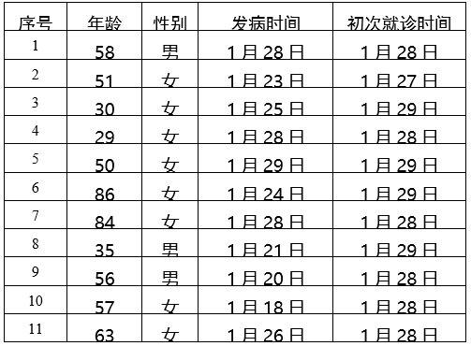

        截至1月30日24时，本市累计确诊病例132例，其中死亡1例，出院5例，126例在市级定点医院进行隔离治疗。东城区3例、西城区13例、朝阳区22例、海淀区26例、丰台区11例、石景山区2例、门头沟区1例、通州区12例、顺义区2例、大兴区16例、昌平区12例、怀柔区1例，外地来京人员11例。房山区、平谷区、密云区、延庆区尚未有病例。